PortSwigger Lab POC - 01-username-enumeration-different-responses

Lab 1 — Username enumeration via different responses

🎯 Objective
Enumerate a valid username via different error messages, then brute-force the password.

Step 1 — Submit invalid login, investigate response
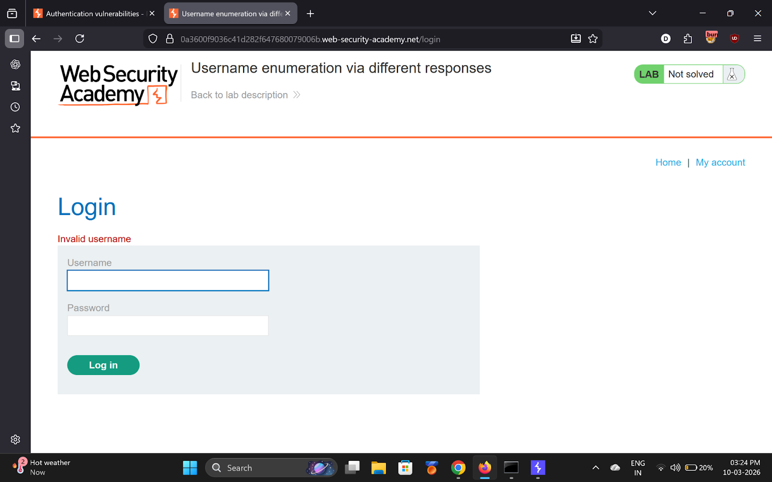

---

Step 2 — Send to Intruder
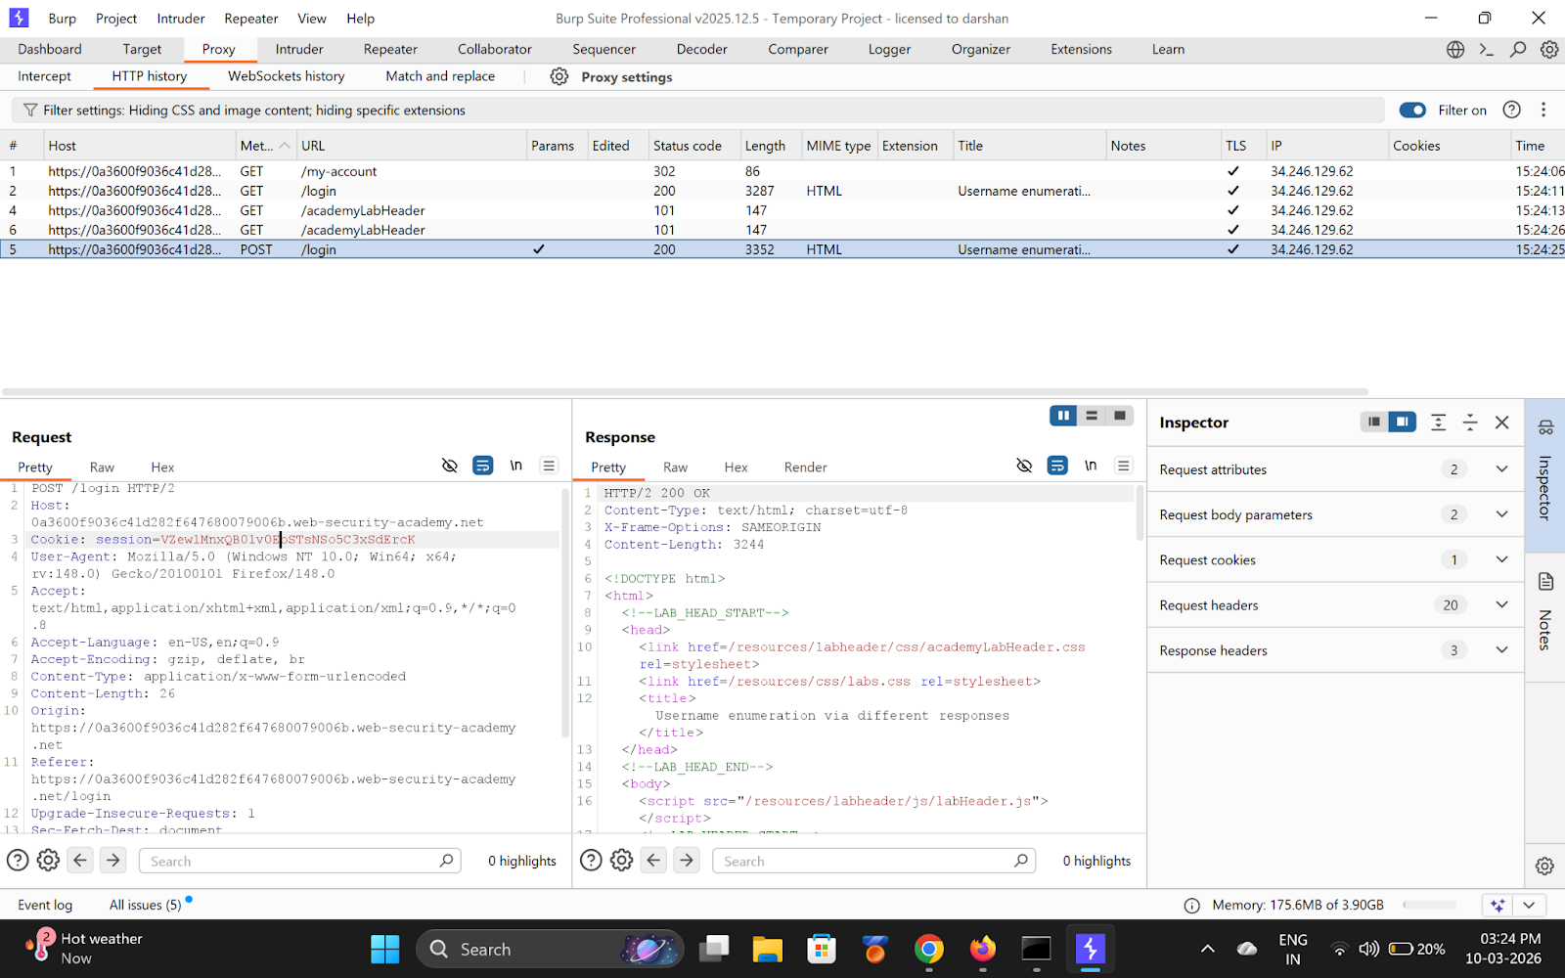

---

Step 3 — Sniper attack on username field
Payload: PortSwigger username wordlist. Look for response where message changes to `"Incorrect password"`.

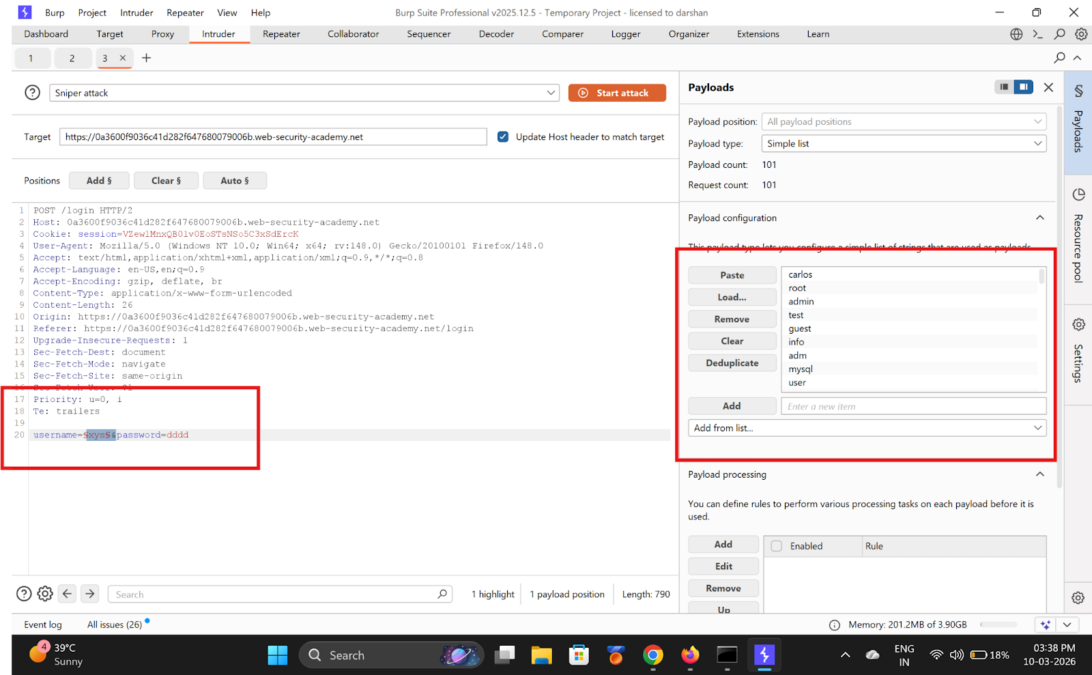

**Found username: `ao`**

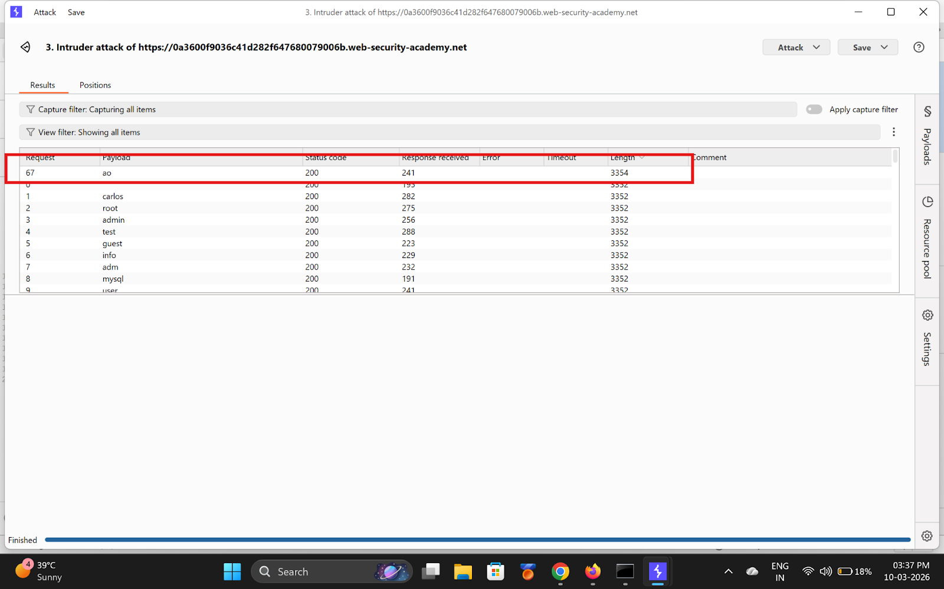

---

Step 4 — Brute-force password
Fix `username=ao`, Sniper on password field.

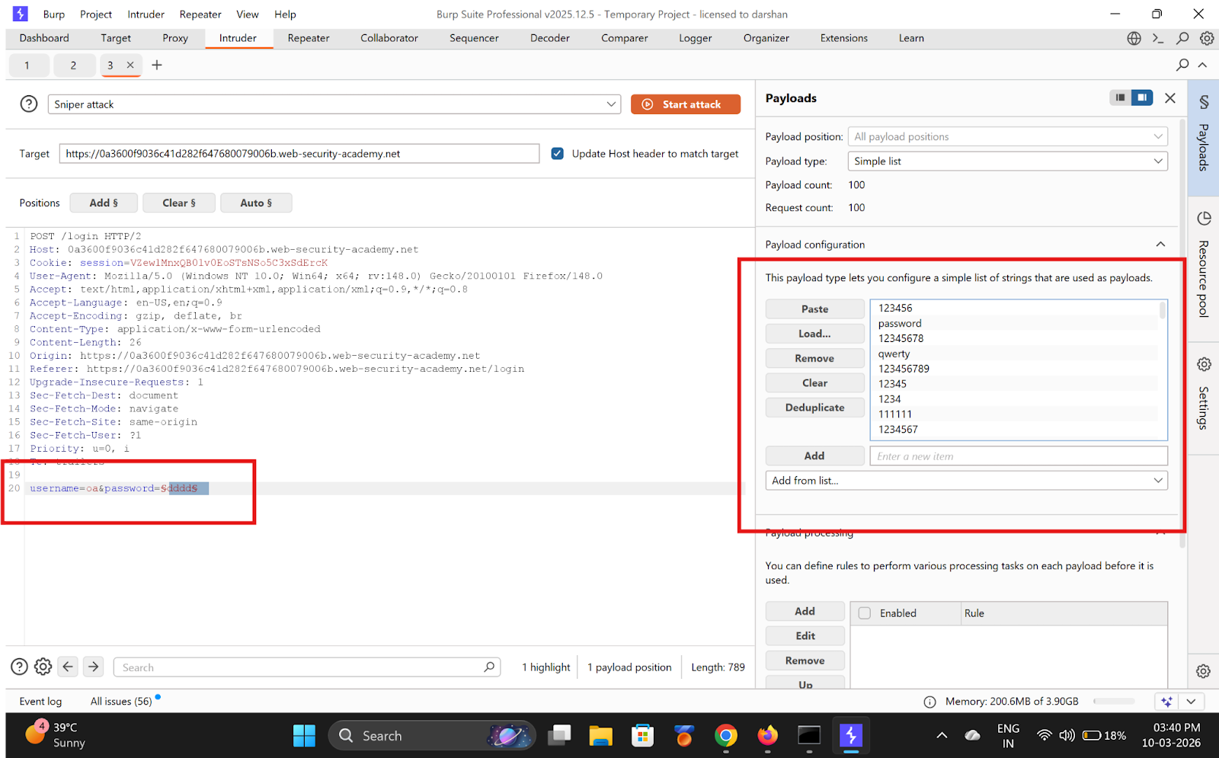

**Found password: `123456`**

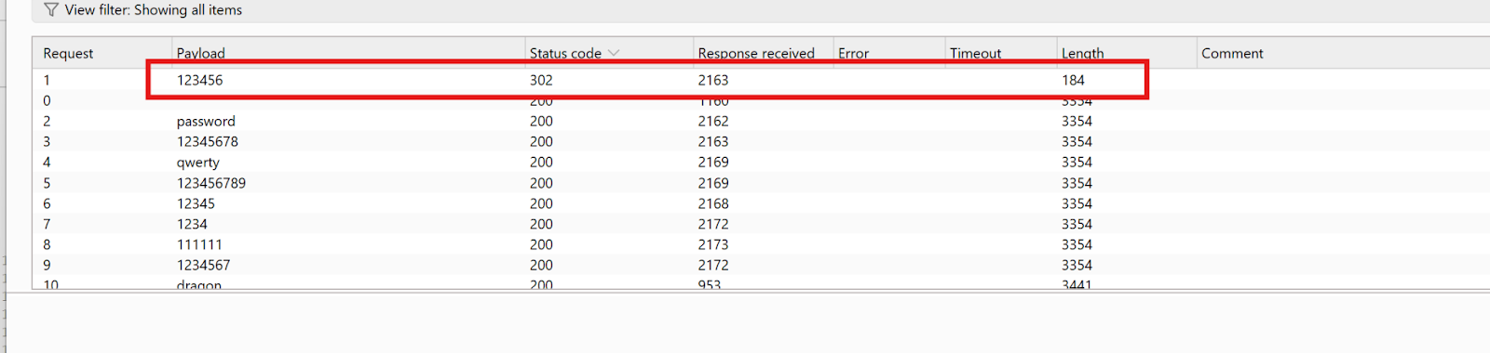

---

Step 5 — Login and solved
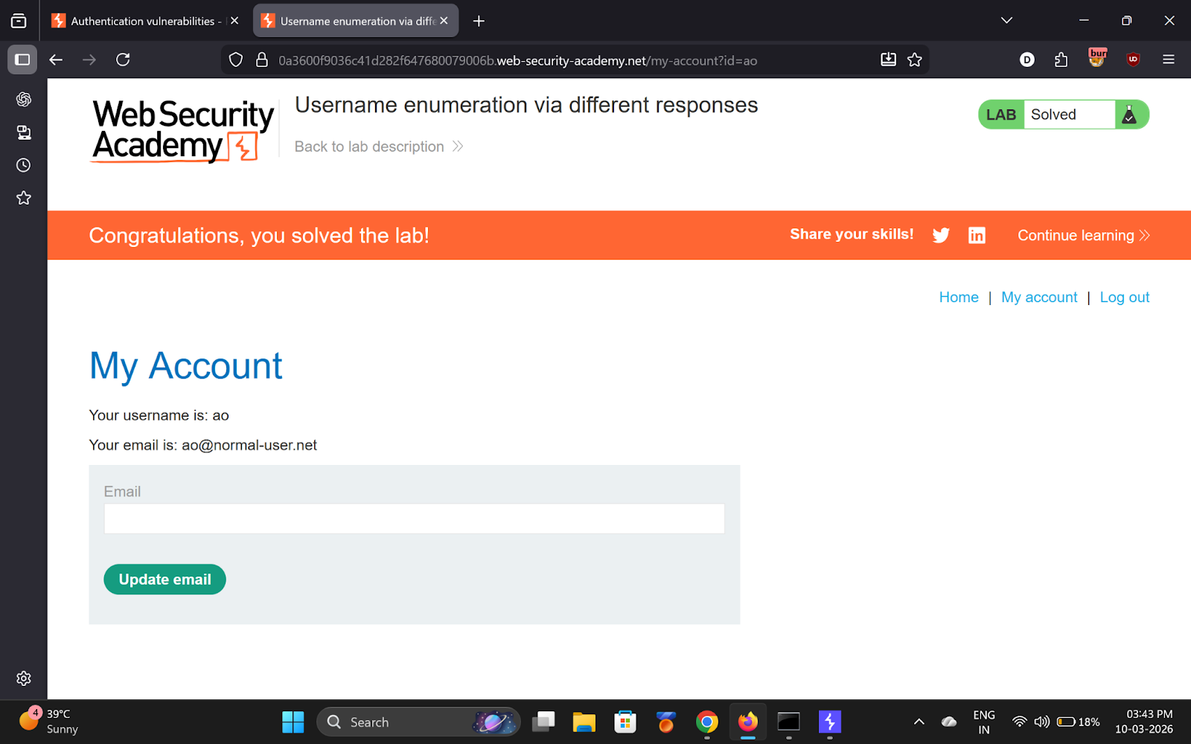

---

✅ Result
- **Username:** `ao`
- **Password:** `123456`

---

💡 Key Takeaway
Different error messages for bad username vs bad password leak which users exist. Always return a single generic error.

